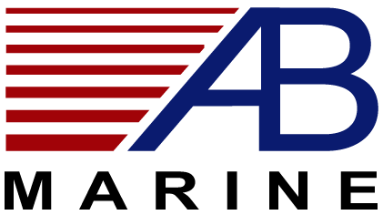

ROLLER BEARING SYSTEM ~ Bearing Replacement Kit

List Prices 2013

H5-RB System:
Description | Qty | $ each | TW Total | TS Total
30203 Bearing | 3 | 36.31 | 108.93 | 108.93
TRI-0218 Lock Screw + Nut (TS) | 3 | 84.15 | 0 | 252.45
Tab Washer + Nut (TW) | 3 | 13.18 | 39.54 | 0
35 x 2mm O ring | 3 | .44 | 1.32 | 1.32
4.5 x 1mm O ring | 6 | .30 | 1.80 | 1.80
M5 x 8mm hex Grease screw | 6 | 3.69 | 22.14 | 22.14
6mm SS balls | 69 | .15 | 10.35 | 10.35
Ecopur seal | 3 | 50.26 | 150.78 | 150.78
Tab Washer (TW)System |  |  | $334.86
Tab Screw (TS) System |  |  |  | $547.77

H6-RB System:
Description | Qty | $ each | TW Total | TS Total
32004 Bearing | 3 | 42.54 | 127.62 | 127.62
51110 Bearing | 3 | 62.16 | 190.50 | 190.50
TRI-0221 Lock Screw + Nut (TS) | 3 | 107.84 | 0 | 323.52
Tab Washer + Nut (TW) | 3 | 19.26 | 57.78 | 0
40 x 2.5mm O ring | 3 | .69 | 2.07 | 2.07
4.5 x 1mm O ring | 6 | .30 | 1.80 | 1.80
M5 x 8mm hex Grease screw | 6 | 3.69 | 22.14 | 22.14
Ecopur seal | 3 | 64.22 | 192.66 | 192.66
Tab Washer (TW) System |  |  | $594.57
Tab Screw (TS) System |  |  |  | $860.31

Note:
Saildrive Roller Bearing systems will require the same components as for the H5 system above

- Prices subject to change without notice
- Prices are FOB Newport, RI

1/1/2013

